**App for registration of person with disability under ADIP scheme**

SUBMITTED IN PARTIAL FULFILLMENT FOR THE REQUIREMENT OF THE AWARD OF DEGREE OF

**BACHELOR OF TECHNOLOGY**

**IN**

**COMPUTER SCIENCE**



Submitted by

Harsh Kumar Vishwakarma 2100290120084

Dheeraj Patwal 2100290120071

Aditya 2100290120014

Supervised by

Prof. Amit Kumar Sengar

Assistant Professor

**Session 2024-25**

**DEPARTMENT OF COMPUTER SCIENCE**

**KIET GROUP OF INSTITUTIONS, GHAZIABAD**

**(Affiliated to Dr. A. P. J. Abdul Kalam Technical University, Lucknow, U.P., India)**

**May 2025**

**DECLARATION**

We hereby declare that this submission is our own work and that, to the best of our knowledge and belief, it contains no material previously published or written by another person nor material which to a substantial extent has been accepted for the award of any other degree or diploma of the university or other institute of higher learning, except where due acknowledgment has been made in the text.

Signature:

Harsh Kumar Vishwakarma Dheeraj Patwal Aditya

2100290120084 2100290120071 2100290120014

13/02/2025 13/02/2025 13/02/2025

## CERTIFICATE

This is to certify that Project Report entitled “App for registration of person with disability under ADIP Scheme” which is submitted by Harsh Kumar Vishwakarma , Aditya and Dheeraj patwal in partial fulfillment of the requirement for the award of degree B. Tech. in Department of Computer Science of Dr. A.P.J. Abdul Kalam Technical University, Lucknow is a record of the candidates own work carried out by them under my supervision. The matter embodied in this report is original and has not been submitted for the award of any other degree.

.

**Date:13/02/25 Supervisor:**

**Prof. Amit Kumar Sengar**

**Assistant Professor**

ACKNOWLEDGEMENT

It gives us a great sense of pleasure to present the report of the B. Tech Project undertaken during B. Tech. Final Year. We owe special debt of gratitude to Professor Amit Kumar Sengar, Department of Computer Science, KIET, Ghaziabad, for his/her constant support and guidance throughout the course of our work. His/Her sincerity, thoroughness and perseverance have been a constant source of inspiration for us. It is only his cognizant efforts that our endeavors have seen light of the day.

We also take the opportunity to acknowledge the contribution of Dr. Ajay Kumar Srivastava, Head of the Department of Computer Science, KIET, Ghaziabad, for his full support and assistance during the development of the project. We also do not like to miss the opportunity to acknowledge the contribution of all the faculty members of the department for their kind assistance and cooperation during the development of our project.

Last but not the least, we acknowledge our friends for their contribution in the completion of the project.

Date :13 February 2025

Signature:

Harsh Kumar Vishwakarma Dheeraj Patwal Aditya

2100290120084 2100290120071 2100290120014

**ABSTRACT**

This project presents a user-friendly web-based application developed to streamline the registration process for persons with disabilities under the ADIP (Assistance to Disabled Persons for Purchase/Fitting of Aids and Appliances) Scheme. The platform enables beneficiaries to create accounts, securely log in, register their details, and access a personal dashboard for tracking requests and application status.

The system provides a structured and transparent environment for managing beneficiary data, updating personal details, and receiving timely updates on pending requests, new government schemes, and feedback schedules. Administrative staff can monitor submissions, review applications, and take appropriate actions through an admin-controlled interface.

Built using Node.js, Express, MongoDB, and EJS, the platform ensures secure data handling, responsive design, and ease of use for both users and administrators. The adoption of this system reduces manual workload, avoids data redundancy, and ensures better transparency and efficiency in implementing the ADIP Scheme.

|  |  |
| --- | --- |
| **TABLE OF CONTENTS** | **Page No.** |
| DECLARATION……………………………………………………………………. | ii |
| CERTIFICATE……………………………………………………………………… | iii |
| ACKNOWLEDGEMENTS…………………………………………………………. | iv |
| ABSTRACT……………………………………………………………………….... | v |
| LIST OF FIGURES…………………………………………………………………. | viii |
| LIST OF TABLES…………………………………………………………………… | ix |
| LIST OF ABBREVIATIONS………………………………………………………. | x |
| SDG MAPPING WITH JUSTIFICATION ………………………………………. | xi |
|  |  |
| CHAPTER 1 INTRODUCTION  1.1 Introduction to Project  1.2 Project Category  1.3 Objectives  1.4 Structure of Report  CHAPTER 2 LITERATURE REVIEW  2.1 Literature Review  2.2 Research Gaps  2.3 Problem Formulation  CHAPTER 3 PROPOSED SYSTEM  3.1 Proposed System  3.2 Unique Features of The System  CHAPTER 4 REQUIREMENT ANALYSIS AND SYSTEM SPECIFICATION  4.1 Feasibility Study (Technical, Economical, Operational)  4.2 Software Requirement Specification  4.2.1 Data Requirement  4.2.2 Functional Requirement  4.2.3 Performance Requirement  4.2.4 Maintainability Requirement  4.2.5 Security Requirement  4.3 SDLC Model Used  4.4 System Design  4.4.1 Data Flow Diagrams  4.4.2 Use Case Diagrams  4.5 Database Design  CHAPTER 5 IMPLEMENTATION  5.1 Introduction Tools and Technologies Used.  CHAPTER 6 TESTING, AND MAINTENANCE  6.1 Testing Techniques and Test Cases Used  CHAPTER 7 RESULTS AND DISCUSSIONS  7.1 Description of Modules with Snapshots  7.2 Key findings of the project  7.3 Brief Description of Database with Snapshots    CHAPTER 8 CONCLUSION AND FUTURE SCOPE  REFERENCES  Research Paper Acceptance Proof  Research Paper (If Presented/ Published)  Proof of patent publication (Screenshot of Publication) |  |
|  |  |

**LIST OF FIGURES**

|  |  |  |
| --- | --- | --- |
| **Figure No.** | **Description** | **Page No.** |
| 4.4.1 | Data Flow Diagram | 15 |
| 4.4.2 | Use Case Diagram | 16 |
| 7.1 | Module Snapshots | 22-23 |
| 7.3 | Database Snapshots | 22-23 |

**LIST OF TABLES**

|  |  |  |
| --- | --- | --- |
| **Table. No.** | **Description** | **Page No.** |
| 6.1 | Test Cases Used | 20 |

**LIST OF ABBREVIATIONS**

SDG Sustainable Development Goals

SDLC Software Development Life Cycle

**SDG MAPPING WITH JUSTIFICATION**

1. **SDG 8 – Decent Work and Economic Growth  
   •** The ADIP registration system enhances efficiency by digitizing the registration and monitoring processes for persons with disabilities, reducing manual work for both beneficiaries and administrators.  
   • By minimizing paperwork and administrative delays, the platform supports faster processing of aid and appliances, allowing beneficiaries to access tools that can help improve their quality of life and economic participation.  
   • It promotes inclusivity and empowers differently-abled individuals to engage more actively in the economy through timely access to government schemes.
2. **SDG 16 – Peace, Justice, and Strong Institutions  
   •** The application ensures transparency and accountability in the implementation of the ADIP Scheme by allowing users to track their application status and receive real-time updates.  
   • A secure login and session management system protects user data and prevents unauthorized access, promoting trust and integrity in public service delivery.  
   • Centralized data handling and structured workflows improve institutional efficiency and governance, aligning with the objective of building strong and just institutions.

**CHAPTER 1**

**INTRODUCTION**

* 1. **Introduction**

The ADIP Scheme Registration System is a dedicated digital platform designed to streamline the registration and monitoring process for persons with disabilities seeking assistance under the Government of India's ADIP (Assistance to Disabled Persons for Purchase/Fitting of Aids and Appliances) Scheme. Traditional offline procedures for registration often involve delays, data redundancy, and accessibility issues, which this web-based application aims to overcome.

This system offers a centralized and secure platform where users can register, log in, update their beneficiary information, and track the status of their requests. Additionally, the dashboard provides personalized updates such as pending requests, newly launched schemes, and feedback schedules. The rationale behind the project is to make the ADIP Scheme more accessible, transparent, and efficient for beneficiaries, ensuring timely delivery of assistance and improving administrative workflow.

.

* 1. **Project Category**

The ADIP Scheme Registration System falls under the category of **Web-Based Applications and E-Governance Platforms**. It is a beneficiary management system that utilizes user authentication, session handling, and a NoSQL database (MongoDB) to store and process user data securely. The project aligns with the domain of **Public Welfare Systems**, **Assistive Technology**, and **Digital Government Services**, and has potential applications in health, social justice, and welfare departments at both state and central government levels.

* 1. **Objectives**

The primary objectives of the ADIP Scheme Registration System are:

* **To provide an accessible online platform** for persons with disabilities to register under the ADIP Scheme without the need for physical visits or paperwork.
* **To facilitate secure and authenticated login/registration**, ensuring only legitimate beneficiaries and authorized personnel can access or modify data.
* **To enable beneficiaries to update personal and medical details** as needed through an easy-to-use dashboard interface.
* **To streamline the application tracking process** by allowing users to monitor the status of their request, view pending actions, and receive scheme-related updates.
* **To reduce administrative delays and errors** through digitized data management, structured form submissions, and automated status updates.
  1. **Report Structure**

This report is structured as follows:

* Chapter 1: Introduction – Provides an overview of the project, its category, objectives, and the structure of the report.
* Chapter 2: Literature Review – Discusses existing systems, their limitations, and how this project improves upon them.

Chapter 3: System Design – Describes the system architecture, database design, and flow of operations.

* Chapter 4: Requirement Analysis and system specification –outlines the functional, non-functional, and system requirements essential for developing the portalefficiently.
* Chapter 5: Implementation -Details the development process, technologies used, and key features of the system
* Chapter 6: Testing and Results – Presents test cases, evaluation metrics, and system performance.
* Chapter 7: Conclusion and Future Scope – Summarizes the findings and suggests possible future enhancements.

**CHAPTER 2**

**LITERATURE REVIEW**

**2.1 Literature Review**

**[1] Dr. S. Gomathi** offers a critical examination of the evolving landscape of government welfare schemes in India, with a particular emphasis on their role in achieving social equity and inclusion. Her work outlines how public policy initiatives, when strategically designed and efficiently implemented, can transform the socio-economic conditions of marginalized communities. She identifies key elements such as decentralization, stakeholder participation, and real-time monitoring as instrumental in ensuring that welfare benefits reach the intended recipients. Furthermore, Gomathi’s analysis underscores that welfare schemes are not merely tools of resource allocation but catalysts for social transformation. She highlights how schemes that address disability not only provide physical assistance but also serve as a medium for psychological empowerment, reducing stigma and promoting dignity among recipients. Her findings serve as a foundational lens for evaluating modern disability-oriented schemes like ADIP, which aim to provide functional autonomy and dignity to persons with disabilities (PwDs).

**[2]** The **Assistance to Disabled Persons for Purchase / Fitting of Aids and Appliances (ADIP) Scheme**, initiated by the Ministry of Social Justice and Empowerment, stands as a flagship program dedicated to enhancing the mobility, functionality, and social integration of PwDs. Launched with the vision of bridging the gap between ability and opportunity, the scheme provides essential aids such as wheelchairs, calipers, hearing aids, smart canes, and prosthetic limbs to individuals from economically disadvantaged backgrounds. The guiding principle of the ADIP Scheme is rooted in the belief that appropriate assistive technology can significantly enhance the quality of life of PwDs by enabling independent movement, self-care, and communication. Studies examining the scheme report increased levels of self-confidence, improved social interaction, and better access to education and employment among beneficiaries. Moreover, the scheme aims to eliminate barriers that hinder the full participation of PwDs in society by empowering them physically and psychologically. The ADIP Scheme also promotes inclusive growth by supporting local manufacturing of assistive devices, thereby boosting the domestic assistive technology sector and creating employment opportunities.

**[3]** Despite its noble intentions and impactful vision, the implementation of the ADIP Scheme has been critiqued for facing several operational challenges that limit its effectiveness. Multiple field studies have documented frequent delays in the disbursement and distribution of aids due to bureaucratic red tape, inefficient logistics, and a lack of coordination among implementing agencies. In rural and remote areas, awareness about the scheme remains low, resulting in poor uptake and exclusion of the most needy individuals. Moreover, inconsistencies in eligibility determination—caused by a lack of standardized disability assessment tools and procedures—have led to grievances and appeals from both beneficiaries and local administrators. Researchers argue that a more dynamic and data-driven beneficiary identification process is essential to ensure fairness and precision. Furthermore, the absence of robust post-distribution support, including repair services and user training, has been identified as a major drawback that compromises the long-term utility of the aids provided.

**[4]** The digital transformation of the scheme through the **ARJUN Portal (Application for Assistance to Disabled for Purchase of Aids/Appliances)** marks a significant policy innovation aimed at reducing inefficiencies and promoting transparency. This web-based platform allows eligible individuals to register, upload documentation, and track the status of their applications from submission to final approval. Early evaluations of the portal show promising results, with significant reductions in processing time, elimination of duplicate applications, and improved data centralization. Researchers have praised the ARJUN Portal for minimizing human error and enabling data-driven policy decisions by aggregating real-time information on scheme utilization across districts. However, the success of the portal is somewhat constrained by digital inequality, particularly among elderly PwDs, those with low literacy levels, or residents of rural and tribal areas with limited internet connectivity. Experts recommend the integration of offline facilitation centers, mobile help vans, and user training programs to ensure that the benefits of digitization are equitably distributed across all segments of the disabled population.

**[5]** A comparative review of global assistive technology distribution models reveals valuable lessons for enhancing the effectiveness of the ADIP Scheme. Countries such as the Philippines, South Africa, and Brazil have implemented successful community-based rehabilitation (CBR) models that emphasize localized delivery, individualized care, and the involvement of family and community members in the rehabilitation process. These models are grounded in the philosophy that disability inclusion is best achieved through community empowerment and the dismantling of structural barriers at the grassroots level. In contrast, India’s approach through ADIP has been largely centralized, with distribution camps and government partnerships with ALIMCO (Artificial Limbs Manufacturing Corporation of India) playing a dominant role. Scholars suggest that decentralizing the distribution mechanism—by involving gram panchayats, local health workers, NGOs, and disabled persons' organizations—could lead to greater customization, better outreach, and higher beneficiary satisfaction. Additionally, such an approach could promote a sense of community ownership and sustainability of the scheme.

**[6]** Research and impact assessments conducted by national institutions such as the **National Institute for Empowerment of Persons with Multiple Disabilities (NIEPMD)** provide strong evidence of the tangible benefits associated with the ADIP Scheme. Beneficiaries consistently report substantial improvements in mobility, independence, and daily living skills. For children, access to assistive devices has a positive correlation with increased school enrollment, academic performance, and participation in recreational activities. For adults, the provision of aids leads to enhanced employability and reduced dependence on family members for mobility and self-care. Psychological benefits such as increased self-esteem, reduced social isolation, and a renewed sense of purpose have also been documented. However, the absence of structured post-distribution services such as user training, maintenance, and technical support often leads to the premature breakdown or abandonment of devices, limiting their long-term impact. Researchers recommend the establishment of regional service centers and technical helpdesks to provide continuous support to users.

**[7]** The intersection of **e-governance and disability inclusion** is another area receiving growing scholarly attention. Experts argue that while digital platforms like the ARJUN Portal represent a leap toward efficient governance, they must be designed with universal accessibility principles. This includes ensuring compatibility with screen readers, multilingual and audio-enabled interfaces, and simplified navigation structures. Additionally, to bridge the digital divide, policymakers must invest in awareness campaigns and provide community-based training, especially for individuals with cognitive or sensory impairments. Studies suggest that combining digital tools with on-the-ground community mobilization efforts can yield a hybrid model of service delivery that is both technologically advanced and socially inclusive. Furthermore, integration of artificial intelligence and big data analytics can enable predictive modeling to identify potential high-need areas, monitor supply chain gaps, and personalize aid delivery.

**[8]** From a policy integration perspective, researchers advocate for aligning the ADIP Scheme with complementary national programs such as **Rashtriya Vayoshri Yojana, Skill India, Accessible India Campaign (Sugamya Bharat Abhiyan), and Ayushman Bharat** to create a holistic support system for PwDs. Such convergence can provide a continuum of care—from assistive device distribution to education, vocational training, healthcare, and financial inclusion. Academic discussions also suggest that multi-sectoral collaborations between ministries (Health, Education, Labor, Rural Development) can result in comprehensive disability empowerment frameworks. There is a call for the establishment of a centralized disability data registry to facilitate cross-scheme tracking, prevent duplication, and ensure that no beneficiary is left behind. The integration of monitoring and evaluation systems, using both quantitative indicators and qualitative feedback, can further enhance the responsiveness and effectiveness of the ADIP Scheme.

**2.2 Research Gaps**

Despite the growing body of research on disability empowerment and assistive device distribution through the ADIP Scheme, several critical gaps remain that hinder its optimization and inclusivity:

* **Limited Use of Advanced Technologies in Assistive Device Allocation:**  
  While the ARJUN Portal has introduced basic digitization, there is insufficient exploration of integrating advanced technologies like AI, machine learning, and predictive analytics to enhance beneficiary profiling, demand forecasting, and personalized aid recommendations.
* **Lack of Research on Digital Accessibility for PwDs:**  
  Existing studies on the ARJUN Portal and similar platforms rarely assess their effectiveness for users with visual, cognitive, or hearing impairments. There is a need for research on inclusive design principles, such as screen reader compatibility, voice navigation, and multilingual support, to ensure universal accessibility.
* **Insufficient Evaluation of Post-Distribution Impact:**  
  While distribution metrics are often reported, few studies have rigorously assessed the long-term social, educational, and economic outcomes for beneficiaries. Research must go beyond quantitative distribution figures and focus on quality of life improvements, device usability, and sustained independence.
* **Underrepresentation of Rural and Marginalized Populations:**  
  There is a noticeable gap in research focusing on the awareness, access, and challenges faced by PwDs in remote and tribal regions. These populations often lack digital literacy and infrastructure, and their experiences with the ADIP Scheme remain undocumented or anecdotal.
* **Absence of Comparative Studies Across Implementation Models:**  
  Few empirical studies have compared centralized camp-based distributions with decentralized, community-driven models. Comparative analysis is essential to determine which approach ensures greater outreach, cost-effectiveness, and user satisfaction.
* **Gaps in Integration with Other Disability Welfare Programs:**  
  The ADIP Scheme is often studied in isolation. There is minimal research on its integration or alignment with broader national initiatives such as Skill India, Accessible India Campaign, or Ayushman Bharat. Exploring synergies across schemes could yield insights into comprehensive disability empowerment.

**2.3 Problem Formulation**

Based on the identified research gaps, this study aims to develop an optimized grievance redressal system that integrates web-based technology for efficient complaint handling in educational institutions. The research will focus on:

* Analyzing the limitations of current grievance management practices in universities.
* Designing a secure, user-friendly digital grievance system to enhance student satisfaction.
* Evaluating the impact of automated grievance handling on issue resolution speed and transparency.

By addressing these areas, this study seeks to contribute to the development of a more inclusive, efficient, and fair management framework.

**CHAPTER 3**

**PROPOSED SYSTEM**

**3.1 Proposed System :**

The system intended for implementation proposes to overcome the shortfalls in current solutions through a novel and effective problem-solving methodology. This system is specifically geared towards enriching user experience, maximizing performance, and reliability by leveraging technology and process simplicity.

Some key goals of the system proposed for implementation are:

* **Increased Efficiency:** The system is built on leveraging automation and maximized workflows that decrease manual work and processing time.
* **User-Friendly Interface:** A user-friendly UI/UX design supports simplicity of usage for all interested parties.
* **Scalability:** Capable of handling future development and changing demands.
* **Security and Privacy:** Offers strong security mechanisms to safeguard user information and system integrity.
* **Real-Time Monitoring and Analytics:** Enables real-time insight and analytics for enabling data-based decision-making.

The system design in question makes seamless integration into current infrastructures possible, enabling smoother adoption for organizations.

**3.2 Unique Feature of the System :**

The system includes a number of innovative features that distinguish it from current solutions. These features improve functionality, enhance efficiency, and ensure a smooth user experience.

* **Automated Workflow Management:** The system manages repetitive tasks automatically, minimizing human intervention and maximizing efficiency.
* **Intelligent Error Detection and Correction**: Detects and corrects errors in real-time, enhancing accuracy and reliability.
* **Multi-Platform Compatibility:** Guarantees access across multiple devices and operating systems.
* **Customizable User Dashboard:** Provides a tailored experience with configurable dashboards for various user roles.
* **Secure Authentication and Data Encryption:** Adopts advanced encryption and multi-factor authentication for secure data.
* **Real-Time Alerts and Notifications:** Sends timely updates on important system operations and anomalies.
* **Seamless Integration with Third-Party Tools:** Enables seamless integration with existing enterprise solutions and APIs.
* **Automated Reporting and Analytics:** Creates detailed reports for informed decision-making.
* **Email Notification for Complete Solution:** Provides an email notification to the users after the issue has been completely solved so that they remain informed and transparent.

**CHAPTER 4**

**REQUIREMENT ANALYSIS AND SYSTEM SPECIFICATION**

* 1. **Feasibility Study :**
* **Technical Feasibility**: Assesses if the intended system can be implemented utilizing current technology and infrastructure.
* **Economic Feasibility**: Examines cost-effectiveness, such as development, maintenance, and operational costs.
* **Operational Feasibility**: Determines the extent to which the system will operate in the specified environment and satisfy user requirements.
  1. **Software Requirement Specification :**

**4.2.1 Data Requirement :**

The ADIP Scheme web application requires structured data storage for user profiles, disability details, supporting documents (income, disability, Aadhar), application records, approval status, and distribution logs. It must support secure storage for authentication credentials and maintain audit logs for tracking user and admin activities. The database should ensure efficient querying, indexing, and regular backups for consistency and disaster recovery.

**4.2.2 Functional Requirement :**

* Users (persons with disabilities) must be able to register, log in securely, and fill in application details for assistive devices.
* Applicants should be able to upload required documents and check the real-time status of their applications.
* The web app should support online grievance registration, response tracking, and resolution status.
* Admins (government officials or implementing agencies) must be able to verify, approve, or reject applications.
* The system should allow implementing partners to view eligible beneficiaries and manage device distribution logistics.
* The platform must support feedback collection after device distribution to assess satisfaction and impact.
* Dashboards and reporting features should be available for monitoring applications, device distribution, and user feedback.
* Role-based access control should be implemented to ensure proper authorization for different user types.

**4.2.3 Performance Requirement :**

* The system should handle multiple concurrent users efficiently.
* Response time for queries should be within a few seconds.
* The application should support scalability to accommodate increasing users and data.
* Data retrieval and processing should be optimized for fast execution.
* The system should ensure smooth performance even during peak usage.

**4.2.4 Maintainability Requirement :**

* The system should follow modular design principles for easy updates and modifications.
* Regular maintenance checks should be performed to ensure smooth functioning.
* Proper documentation should be maintained for future reference.
* The code should be well-structured and follow best practices.
* Bugs and errors should be easily traceable and fixable without affecting system performance.

**4.2.5 Security Requirement :**

* All user data, including personal details, disability certificates, and income proofs, must be securely encrypted during storage and transmission.
* Secure login and session handling should be implemented for beneficiaries and administrators, with OTP verification for account creation and password reset.
* Role-based access must be enforced—beneficiaries, administrators, and scheme verifiers should only access data relevant to their role.
* Document uploads must be validated and stored securely to prevent unauthorized access or tampering.
* The system should log all access and update activities for audit purposes, ensuring traceability and accountability.
* Regular security checks and compliance with data protection guidelines (such as the Indian IT Act) should be ensured to maintain user trust and system integrity.
  1. **SDLC Model Used :**

The **Agile SDLC** model is chosen due to its iterative approach, allowing continuous feedback and improvements. Frequent testing and modular development ensure adaptability to changing requirements. This model enhances collaboration among developers, testers, and stakeholders for better project outcomes.

* 1. **System Design :**

**4.4.1 Data Flow diagram**

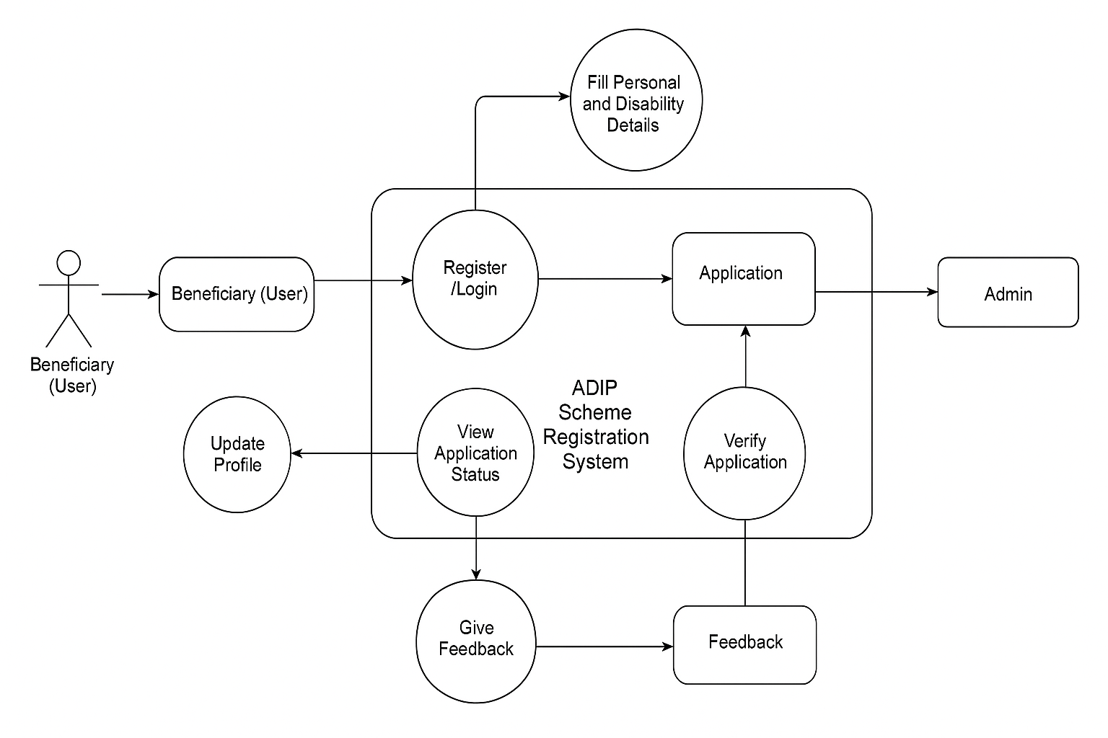

* + 1. **Use Case Diagram :**

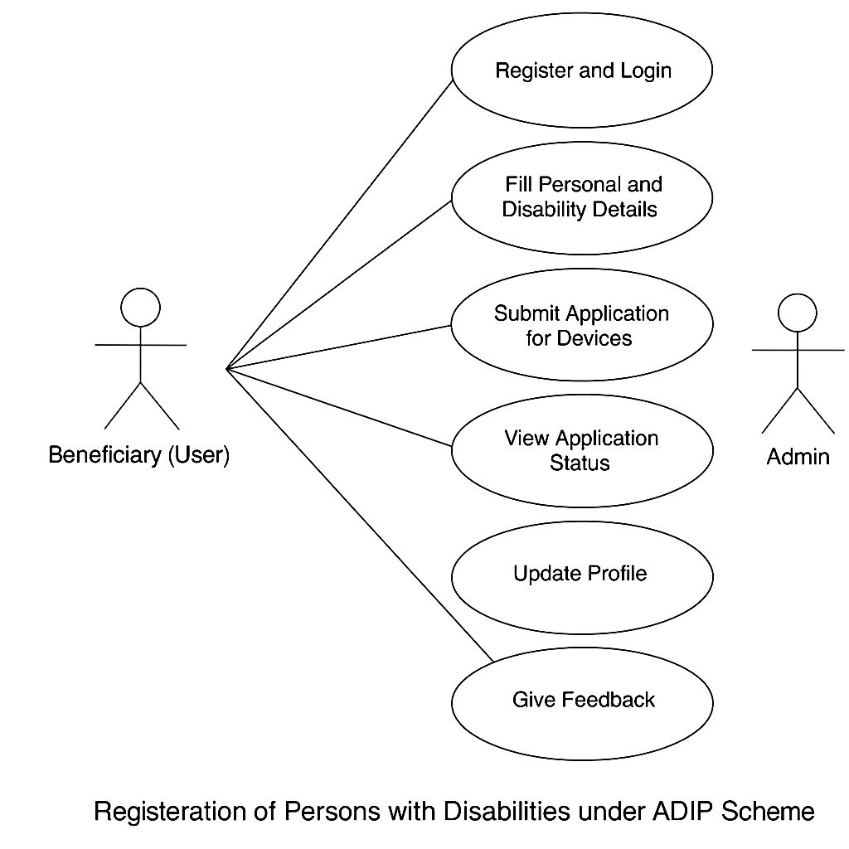

* 1. **Database Design :**

The database for the **ADIP Scheme Registration System** is designed using **MongoDB**, structured around multiple collections representing key entities involved in the scheme’s workflow. The design follows **NoSQL principles**, enabling scalability, quick access, and efficient data handling for both beneficiaries and administrators.

The key collections are:

1. **User Collection**:  
   Stores information of all registered beneficiaries, including name, age, gender, contact number, Aadhaar number, disability type, and login credentials. Passwords are stored securely using hashing. This collection also links each user to their submitted documents and application status.
2. **Application Collection**:  
   Contains detailed information about each user's application for disability aid under the ADIP scheme. Fields include application ID, user ID (as reference), uploaded documents (e.g., disability certificate, income proof), application status (e.g., pending, verified, approved, rejected), and timestamps for each update.
3. **Admin Collection**:  
   Stores credentials and profiles of administrative users responsible for reviewing and verifying applications. Admins can update application statuses, leave remarks, and access beneficiary details for verification.
4. **Scheme Collection**:  
   Contains information about available assistive devices and schemes under ADIP. This includes scheme names, descriptions, eligibility criteria, and distribution dates. Admins can update or add new schemes to this collection.
5. **Feedback Collection**:  
   Captures user feedback after receiving support or facing issues. Fields include user ID, message, date of submission, and admin response (if any). This helps maintain transparency and improve service quality.

**CHAPTER 5**

**IMPLEMENTATIONS**

**5.1 Introduction Tools and Technologies Used.**

The ADIP Scheme Registration System is built using modern web technologies to ensure a secure, scalable, and user-friendly platform for registering and managing applications of persons with disabilities seeking aid under the ADIP scheme. The system comprises two main sections:

* User Section: Beneficiaries can register, log in, fill out their disability application form, upload required documents (e.g., disability certificate, income proof), track their application status, and submit feedback.
* Admin Section: Admins can log in to verify documents, update application statuses (e.g., pending, verified, approved, rejected), respond to feedback, and manage scheme-related announcements.

**Tech Stack & Tools Used -**

Frontend Development:

* **EJS (Embedded JavaScript Templates)** – Provides dynamic rendering of pages using data from the backend.
* **HTML/CSS and JavaScript** – For building user interfaces with responsive and accessible design.
* **Bootstrap or Tailwind CSS** – For clean, responsive, and mobile-friendly styling.

Backend Development:

* **Node.js with Express.js** – Manages routes, handles form submissions, and implements the business logic for processing applications and admin functions.
* **Multer** – Handles file uploads (e.g., scanned certificates and ID proofs).
* **Nodemailer** – Sends system-generated emails to notify users of status updates or feedback responses.

Database Management:

* • **MongoDB (NoSQL Database)** – Stores user data, application details, feedback, admin records, and scheme information in structured collections.
* • **Mongoose (ODM for MongoDB)** – Facilitates schema-based data modeling for organized and efficient CRUD operations.

Authentication and Security:

* **JWT (JSON Web Tokens)** – Ensures secure session management for both users and admins.
* **BCrypt.js** – Hashes passwords to protect against credential leaks.
* **Express Validator & Middleware Security** – Validates form inputs and guards against threats like XSS, CSRF, and injection attacks.

**CHAPTER 6**

**TESTING, AND MAINTENANCE**

**6.1 Testing Techniques and Test Cases Used.**

The ADIP Scheme Registration System underwent thorough testing to ensure its reliability, usability, and security. The testing process included the following stages:

1. Unit Testing:

* Each backend route, such as user registration, login, form submission, and admin approval, was tested individually to ensure correctness of logic and expected responses.

1. Integration Testing:

* Verified the flow between frontend forms and backend APIs, ensuring seamless interactions such as file uploads, form validation, and database updates.

1. User Acceptance Testing (UAT):
   * Verified the system from the perspective of end users and administrators.
2. Security Testing:
   * Used Express Validator to sanitize user inputs and JWT authentication to prevent unauthorized access.
3. Performance Testing:
   * Tested API response times, database queries, and system scalability under heavy loads.

Test Cases used :

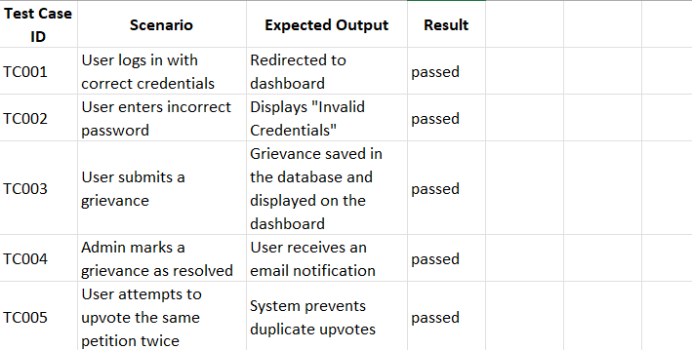

**CHAPTER 7**

**RESULTS AND DISCUSSIONS**

**7.1 Description of Modules with Snapshots:**

The system consists of two key modules:

1. Beneficiary Module

* **Registration & Login**:  
  Users can register and log in using a secure authentication system.
* **Application Form Submission**:  
  After login, users can fill out the ADIP scheme application form with details such as name, age, type of disability, and required assistive devices.
* **Document Upload**:  
  Users are required to upload necessary documents (disability certificate, identity proof, etc.), which are validated on the server side.
* **Dashboard View**:  
  Users can view the status of their submitted application (e.g., Pending, Approved, Rejected) along with the date of submission and admin feedback, if any.
* **Profile Update**:  
  Users can update their profile and re-upload documents if requested by the admin.

2. Admin Module

* **Admin Login**:  
  Admins log in through a separate secure portal.
* **User Application Review**:  
  Admins can view all submitted applications in a tabular format along with uploaded documents and user details.
* **Application Approval or Rejection**:  
  Admins can change the status of the application after verifying details. When an application is approved or rejected, an automated email notification is sent to the user.
* **Scheme and Feedback Management**:  
  Admins can post updates on newly launched schemes or feedback forms. These updates are shown on the user dashboard.
* **Pending Requests Section**:  
  A separate section displays all pending applications for quick review.

**7.2 Key Findings of the Project :**

* **Streamlined Registration Process**:  
  The project successfully digitizes the registration process for beneficiaries under the ADIP scheme, reducing paperwork and manual errors.
* **User-Friendly Interface**:  
  A simple and accessible user interface ensures that individuals with disabilities or their caretakers can easily navigate the system to submit applications.
* **Efficient Document Management**:  
  The platform enables secure and organized storage of essential documents such as disability certificates and ID proofs, improving administrative efficiency.
* **Real-Time Application Status Tracking**:  
  Users can view the real-time status of their application (Pending, Approved, Rejected), enhancing transparency in the approval process.
* **Admin Dashboard for Quick Review**:  
  The admin module provides a centralized view of pending applications, helping authorities prioritize and process requests more efficiently.
* **Automated Email Notifications**:  
  Integrated email alerts notify users about the status of their application, ensuring timely communication and reducing manual follow-ups.
* **Scalable and Secure Architecture**:  
  Built using Node.js, MongoDB, and Express, the system is scalable for future enhancements and includes secure authentication with role-based access.
* **Improved Monitoring of Scheme Utilization**:  
  The centralized database allows for easy tracking of how many beneficiaries applied, were approved, and which assistive devices were requested.

**CHAPTER 8**

**CONCLUSION AND FUTURE SCOPE**

**REFERENCES:**

[1] R. Dhar and C. Roy, "ADIP Scheme: An Analytical Overview," *National Institute of Labour Economics Research and Development*, 2023.

[2] Department of Empowerment of Persons with Disabilities, "Evaluation Study on the Scheme of Assistance to Differently Abled Persons for Purchase/Fitting of Aids/Appliances (ADIP)," *Development Monitoring and Evaluation Office*, Govt. of India, 2019.

[3] K. Rana and P. Thappa, "Status of Assistive Devices and Technologies in India," *Paripex - Indian Journal of Research*, vol. 9, no. 7, pp. 28-30, Jul. 2020.

[4] International Journal of Research Publication and Reviews, "Assistance to Disabled Persons (ADIP) Scheme," *IJRPR*, vol. 5, no. 5, 2023.

[5] Department of Empowerment of Persons with Disabilities, "ADIP Scheme – Central Scheme for Assistive Devices," *Govt. of India*, 2024.

[6] R. Mehrotra, A. W., P. Srivastav, and R. Sharma, "A Study of Outcomes Following Cochlear Implantation in Children under ADIP Scheme—An Indian Experience," *Online Journal of Otolaryngology and Rhinology*, vol. 2, no. 5, Jun. 2020.

[7] A. K. Singh and P. Thakur, "A Comparative Study of Cochlear Implant Outcomes under ADIP and Self-Financed Schemes," *Disability, CBR & Inclusive Development*, vol. 32, no. 1, pp. 45–58, 2021.

[8] R. K. Sharma, "Inclusion of Aids & Assistive Devices for Distribution under ADIP Scheme in Respect of Disabilities Included in the RPwD Act, 2016," *The National Trust*, 2020.

[9] S. K. Gupta, "Disability Justice as Part of Structural Competency: Infrastructures of Deafness, Cochlear Implantation, and Rehabilitation in India," *Health and Human Rights Journal*, vol. 25, no. 1, pp. 123–135, Feb. 2023.

[10] P. R. Desai, "Status of Assistive Devices and Technologies in India," *ResearchGate*, 2022.